Filing a Noise/Curfew Complaint For
The Van Nuys Airport:

https://viewpoint.emsbk.com/vny1

LA CITY ORDINANCES OF NOTE:
View detailed information here:
https://www.lawa.org/-/media/lawa-web/environment/files/noise-mgt/van-nuys--complete-curfew-ordinance-revised.ashx

155727: Basic Curfew Ordinance (No take-offs between 11pm – 7am)
171889: Additional Curfew Hour (No take-offs between 10pm – 11pm)
181106: Noiser Jet Phase Out (Max noise allowed at any time:
As of Jan 1, 2014 = 80dB. As of Jan 1, 2016 = 77dB.)
173215: The Non-Additional Rule

USEFUL SITES:
ADS-B Exchange
Find the tail number (N Number) of an aircraft and view it’s real-time flight path with this free service: Find the offending aircraft by visiting https://globe.adsbexchange.com. Click on the aircraft in real time and view its details.

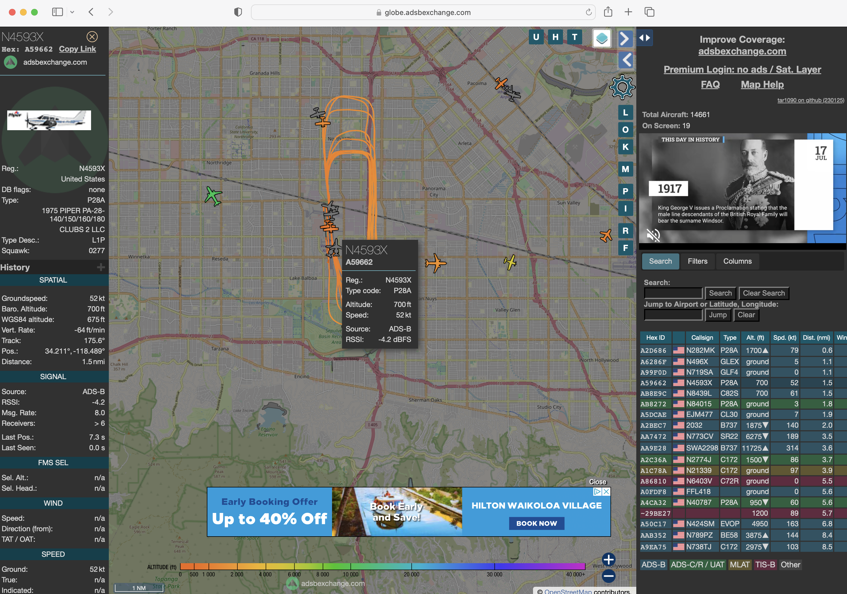

VNY Noise Management:
https://www.lawa.org/lawa-environment/noise-management/van-nuys

VNY Noise Comments (all options):
https://www.lawa.org/lawa-environment/noise-management/van-nuys/vny-noise-comments

VNY Noise Comment Summary Reports:
https://noiseportal.lawa.org/vny

VNY Flight Path Information:
https://www.iflyvny.com/-/media/iflyvny/vny-pilot-information/files/vnypilotguide.ashx

SFV Airplane Noise Task Force:
https://www.lawa.org/lawa-environment/noise-management/van-nuys/joint-task-force

HOW TO FILE A COMPLAINT:

There are two preferred methods for submitting noise complaints to VNY and LAWA (Los Angeles World Airports). PLEASE DO LOG YOUR COMPLAINTS! VNY and LAWA cannot fine the flights if we do not log the violations. The community must report these violations to keep them in check. Otherwise these problems will only become more frequent and much worse.

Preferred Methods:

- Visit https://viewpoint.emsbk.com/vny1 on your computer.
  - Bookmark or save the site to your browser for quick and easy access.
  - Fill out your user information and check the box “Remember my details.” This will allow you to log-in faster and prefill your information when submitting a noise complaint. It will also allow you to receive emailed responses from VNY so that you can document your complaints.
  - Fill out the noise comment details by selecting the proper concern from the drop down menus. Be sure to select the date and time of the offending aircraft.
  - Enter any additional details in the comments box. If you have the tail number of the aircraft or serial number of the aircraft, enter it in this field.
NOTE: ALWAYS CHECK THE DATE AND TIME OF THE NOISE EVENT AS THE SITE FREQUENTLY RESETS THIS INFORMATION TO THE CURRENT TIME AND DATE.

- Use the mobile “app” site located at https://viewpoint-app.emsbk.com/vny1 on your iPhone or Android device.
  - Bookmark or save the site to your mobile browser for quick and easy access.
  - Click “sign up” then enter and save your details. This will ensure you can receive emailed responses from VNY so that you can document your complaints.
  - Follow the prompts and use the drop down menus to submit your complaint.
  - Enter any additional details in the comments box including the tail number of the aircraft if available.
NOTE: ALWAYS CHECK THE DATE AND TIME OF THE NOISE EVENT AS THE SITE FREQUENTLY RESETS THIS INFORMATION TO THE CURRENT TIME AND DATE.

